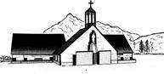

Pastor Debra Jimenez
Cell: 770-841-7610
Email:
pastordebra.ascension@gmail.com

Parish Notes
Welcome to Worship

September 11, 2022

1105 N Washington Blvd
Ogden, UT 84404
801-782-2810

Gathered and gifted to celebrate and share the love of Jesus

-

SUNDAY 9:30 am - Worship
10:30 am - Fellowship
11:00 am - Adult Bible Study
11:00 am - Teen Sunday School

MONDAY 9:00 am - Friendly Ties Quilters (1st & 3rd Monday’s)

WEDNESDAY 9:00 am - Yoga
1:00 pm - Book Club
6:00 pm - Faith Formation/Confirmation

THURSDAY 1:00 pm - Shepherding Bible Study Group – (3rd Thursday)
6:30 pm - Church Council meeting – (2nd Thursday)

FRIDAY 8:00 pm - AA and Al Anon

Lined through events are off for the summer.

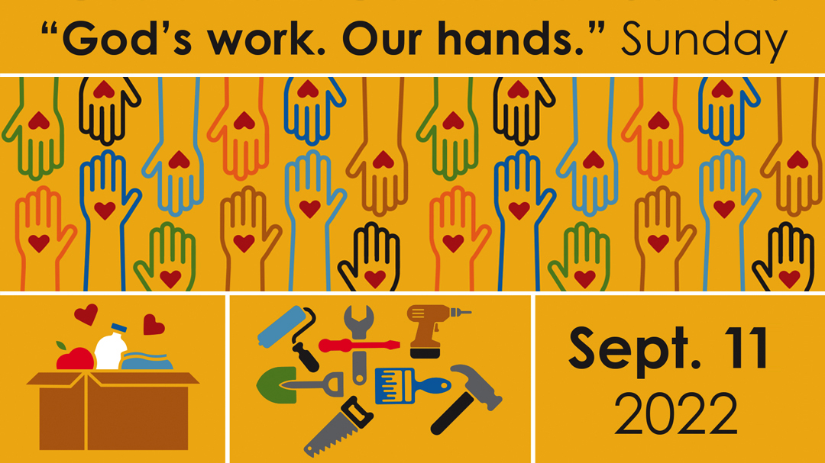
September Birthdays
Bob Bezyzck 2
Jim Craig 4
Linda Fallat 6
Tyson Wallace 6
Pastor Debra 28
Linda Corey 10
Titus Hughes 14
LaDonna Stephens 23
Olivia Day 25
Vicki Allred 30
Upcoming Events
Aug 31 – Book Club 1 PM
Sep 15 – Rise & Shine Breakfast
Sep 15 – Council Meeting
Sep 18 – Interfaith Concert
Sep 22 – Bishop Gonia’s Town Hall Mtg
Oct 28-29 – Yard Sale



Many thanks to Arliss for providing treats for this morning as we go out to do our service in the community.

Flowers on the altar
this morning are given by
Diana and John Warkentin
in honor of their
52nd wedding anniversary.


I want to thank everyone who helped with Brigitte's funeral luncheon. Those who set up, those who put away. The plates, the flowers, the vegetables and fruit. Those who baked desserts, and those that gave money for the sandwiches. With all your donations I think we surrounded the Schultz family with our love. They expressed their gratitude many times. Thank you for making it a day of celebration.
Most sincerely, Arliss Zimmerman

The Book Club will be starting a new book, Learning to Walk in the Dark, by Barbara Brown Taylor, this week. Extra books have been ordered. All are welcome to join us at 1:00 p.m. Wednesday, September 14, 2022. Hope to see you there!

Shepherding Group – September 15, at 1:00PM, Shepherding will take place in the Fellowship Hall. Over the next several months we will be looking at the Catechism and its prevalence in today’s life. This is a great review of The Commandments, The Apostles Creed, and The Lord’s Prayer. Please join us for a lite dessert and open discussion. Arliss Zimmerman will be leading this series as she tries to fill the big shoes of our past leader, Don Brown. Don will be there, to provide a great support of this group.

TOWN HALL GATHERING WITH
BISHOP JIM GONIA
Worried about your congregation today?
Wondering what the future holds?

You are not alone. People throughout the church are experiencing doubts, fears, and uneasiness about the future. Bishop Gonia would like to talk with you about the worries and wonders you are experiencing. Together we will ponder how our congregations’ ministry and witness can be shaped for the sake of the gospel.
If you are invested in our Church’s future... join us!
Thur., Sept. 22, 2022: 6pm-8pm at Our Saviour’s Lutheran Church, Holladay UT

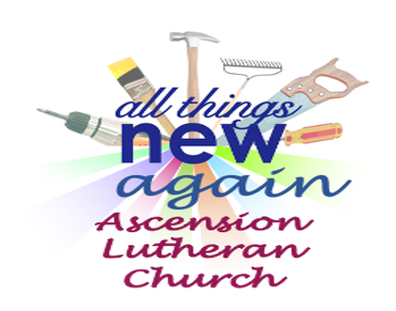
Capital Campaign - Don’t Forget Your Commitment Cards!!
We will continue to collect donations/commitments for the Capital Campaign. We have received 25 commitments, currently totaling $29,041. With seed money and previous donations, our current anticipated/collected funds stand at $34,891.
Capital Campaign Commitment Cards are available in the Narthex and can be placed in the Offering Plate or given to Pat Refsdal or Kelly Martin. Please annotate “For Capital Campaign” on your donations for the capital campaign. We will also accept commitment cards at any time through December, if needed. Thank you for your generosity!!

Yard Sale dates Oct. 28th and 29th 8:00 - 1:00. Turn your clutter, junk, and unused treasures into a Blessing for the Church. Trash for Cash.
Items can be dropped off at the Church after worship, or you can call Kelly or Pastor Debra to coordinate a time during the week. If you need larger items or are unable to bring your appreciated donations to the Church, please call Diane Schultz at 801-710-5701.
We are hoping to exceed last year’s fundraising of $3,000 but we need things to sell! Ask your friends and neighbors. Please sign up to Volunteer. It’s going to be a fun time. Sign-up sheets are in the Narthex.
Thank you in advance for your time and support!! There will be a planning meeting after Church on Sept 18th. You’ll be able to join via Zoom also.

Please Lift Up in Prayer:
- The Family of Brigitte Schultz
- Tracie Truitt, friend of Alyson’s
- Kristy - Shari Morosky’s daughter
- Bruce & Joan Marlow
- Cory, Nancy Gale’s son
- Pam Burbank
- Jessica Stewart, Dick Graves’s daughter
- Rebecca Rens and the Eyre Families
- Jefferson Barrett
- Mark Baird
- Maylan Chugg, Don & Dee’s granddaughter
- Gloria Mike
- Chris, friend of Alyson W.
- Judy Sherman
- Henry, Nancy G’s grandson
- Justina, friend of Rebecca
- Lynn Copper and her family
- Sean Zeller, Pastor Gene’s nephew
- Cheryl, friend of Alyson
- Mark Hughes and family
- Richard, Shari Morosky’s husband
- Erik Thompson
- Pat, Lillian’s Sister in Law
- Scott, Diana & John’s son
- Heidi, Diane Shultz’ sister-in-law
- Dick Graves
- Bob P.
- Shari Morosky and her family
- Dee Brown
- PJ, friend of Kelly
- Toni, Pastor Debra’s Sister-in-Law
- Lynn and Carol
- Roxannne, David’s sister
- Carol and Jean, friends of Sharen
- Cindy C.
- Brigitte S.
- Carol Reopelle
- Kim, friend of Bob
- Jack, Pastor Debra’s nephew
- Suzy and her family
- Grace Scothern
- Dallin, friend of Rachel F.
- Bill, Linda’s brother
- Scott Chapan, friend of Dick G.
- Linda, John, Jeff, Pr Gordon’s sister and her family
- Alice, Anastasia, and all of the people affected by the war
- Levi
- Brian Washburn, Kamberlynne’s dad
- Jeni, friend of Nancy O
- Kemzey, Cindy’s niece
- Lacey, friend of Cindy D.
- Kallee, Rachel’s sister-in-law
- Bob, Rachel’s uncle
- Bob, friend of James
- Jeff Debick
- Terry, Dee Brown’s brother
- Heidi, Linda Fallat’s daughter
- Carla, friend of Don Hughes
- Jamie, friend of Nancy Otto

Praying for Loved Ones in the Military:
- Steve Johnson
- Kaleb Tarr, Ethan Lee, Michael Connelly (deployed 13 July 17, 2021)
- Dariyan Edsinger
- Mason Bushey and his wife Ida, and family
- Brody Wilcock
- Renee Kiel
- Justin Kiel
- Kris Kiel
- Matt Malde
- Jason Chugg

August
Ascension Ministries

  SUN | Worship Asst | Altar Guild | Ushers |   Greeters | Announce-ments | 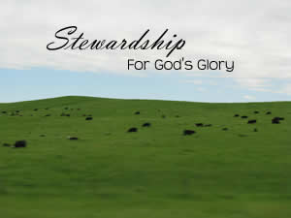  Counters
Sep 4 | Patti Hall | Kim Engelby | Todd & Renee Hart | John & Diana Warkentin | Jim Craig | Renee Hart
Sep 11 | Arliss Zimmerman | Kim Engelby | Patti Hall & Stef Rhees | ??? | Jim Craig | Paula DelCarlo
Sep 19 | Mike Hughes | Kim Engelby | Sharen Kamp | Stefani Rhees | Jim Craig | Keith Sorbo
Sep 25 | Katy Young | Kim Engelby | James Jimenez | CJ Jordan | Jim Craig | CJ Jordan

